**Operation and installation instructions for the Hydraulic Bollard** 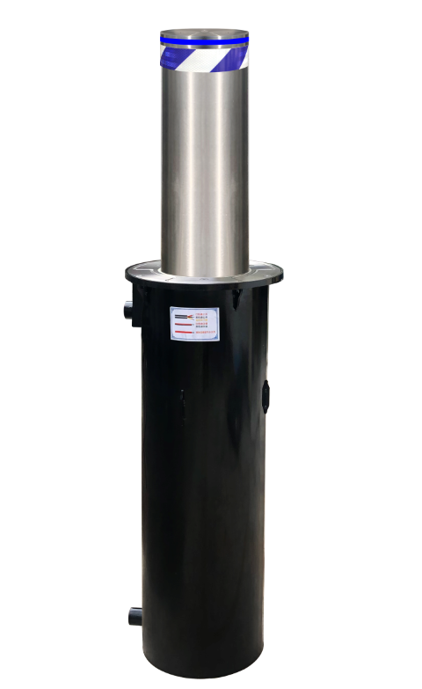

**一、Product presentation**

The fully automatic electromechanical-hydraulic integrated lifting column is a complete set of miniature hydraulic drive system composed of a micro motor and an integrated hydraulic cylinder. The system is built into the lifting column through structural parts, and each lifting column is an independent unit. , the perfect realization of the integration of microcomputer, electricity and liquid.

The control mode is flexible and flexible. In addition to conventional manual remote control, it can also be controlled by short-range station control remote control, long-distance remote control, short-range card swiping, remote card reading, license plate recognition, etc., and can be programmed through a computer.

**二、 Functional characteristics**

Integrated hydraulic lift column characteristic advantages：

1. There is no hydraulic drive system outdoor room on the ground, to save the ground space, the overall more beautiful;

2、There is no hydraulic drive system outdoor room on the ground, to save the ground space, the overall more beautiful;

3、A single failure does not affect the use of other cylinders；

4、Removable structure, to achieve the targeted replacement of single part damage and single part；

5、Suitable for grouping control in more than two groups。

**三、Product technical parameters**

|  |  |
| --- | --- |
| Bollard diameter | 168/219/273mm |
| Bollard wall thickness | 6mm/8mm/10mm |
| Cover thickness | 8-10mm |
| Bollard material | 304 Stainless steel |
| interception height | 600mm（±10mm） |
| ascent rate | 3-4s |
| speed of decent | 1.5-2s |
| drive | Hydraulic electromechanical integrated drive |
| Operating Voltage | 220V/50HZ |
| rated power | 350W |
| usage frequency | 200 Times / day |
| Dimensions | Diameter * high：395*1110（±10mm） |
| Protection class | IP68 |
| Warning method | Interior acrylic plate + super engineering grade reflective belt + LED lamp) |
| Operating temperature | -35℃-60℃ |
| surface treatment | Stainless steel finish with a polished / brushed finish |
| waterproof level | IP68 Up. Test the bubble water above 120H, the motor contains a thermal protection device. |

This manual is applicable to the installation, application and daily maintenance of the lifting columns produced by our company. Please read this manual carefully before installation and use.

**四、Install the preparation tools and accessories**

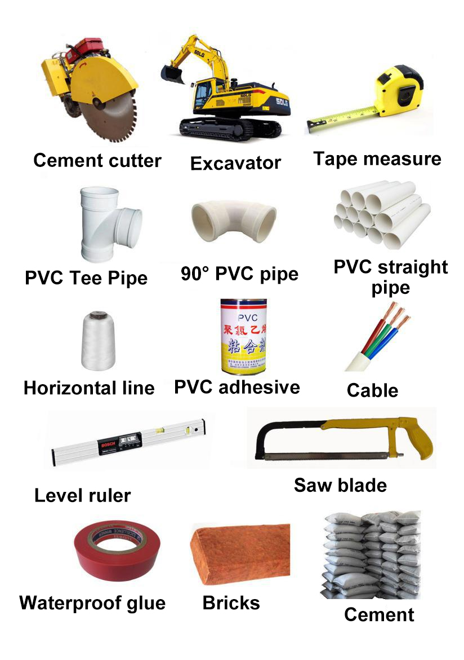

Preparation tools: cement cutter, excavator, tape measure, nylon rope, small Phillips screwdriver, small flat-blade screwdriver, waterproof

Tape, electrical tape, ∮50mm PVC pipe (straight-through, several tee); one 4 square two-core cable, M6 Allen wrench, several 2.5 square three-core cables; several 1.0 square four-core cables; three-core butt waterproof connection Several connectors; several four-core waterproof connectors.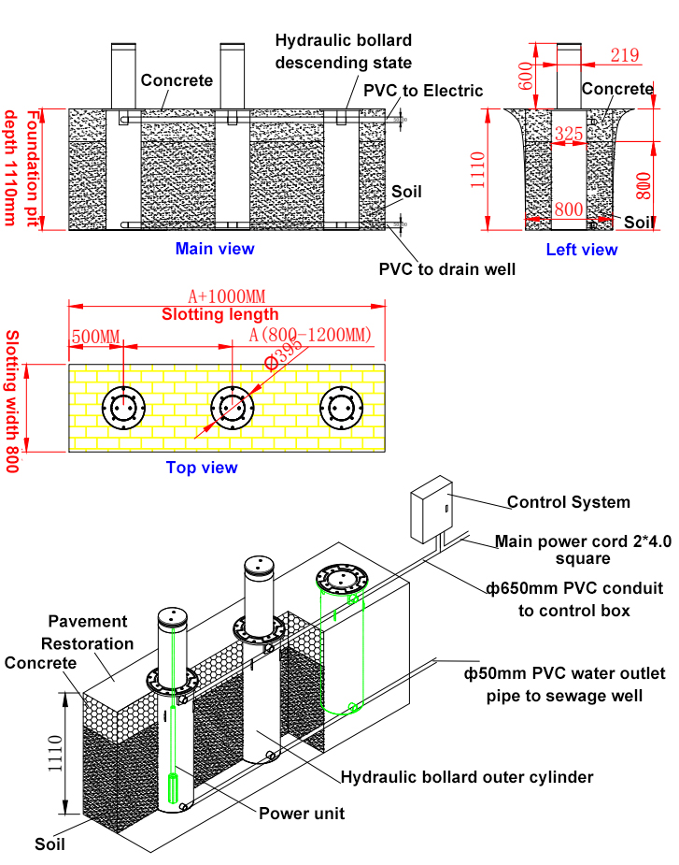

1. **Installation and commissioning requirements**

1、Construction site requirements: According to the provided dimensions, length N (depending on the number of installations) × width 800mm × depth 1110mm, dig foundation pits and compact them to prevent equipment from sinking.

1. Installation: Put the hydraulic bollard into the pothole. After determining the installation position, pull the wire, position it, and level it. The upper surface of the lifting column is slightly higher than the ground by 3~5mm.
2. Pre-embedded conduit: place the product on the leveled foundation pit, and pre-embed the conduit according to the position of the outlet hole reserved on the surface of the outer barrel. The diameter of the threading pipe is determined according to the number of hydraulic bollard. The main power cable of the control box is 4 square two-core wires. The specifications of the cables required for each bollard are one 1.5 square three-core wire and one 1.0 square four-core cable. , Note that the cables coming out of the control box must be pulled into the outer cylinder of the bollard and fixed with nylon sleeves twice (tie them together to prevent the cables from falling below the flange). The wiring interface must be in the bollard cylinder and cannot be pulled PVC pipes, otherwise it will be very inconvenient for later maintenance), and the specific use should also be determined before construction according to the needs of the use site and the difference in power distribution.

4、Pouring: first place the bollard at a distance of 1200mm (the installation interval is determined before construction according to different site conditions), put the equipment into the pit, backfill with appropriate amount of sand, fix the equipment with stones, and then use C30 concrete to pour slowly and evenly until it reaches the top of the equipment. surface level.

(Note: the bollard must be fixed during pouring to prevent it from being moved and dislocated to make it tilted during pouring), then connect the power (note that the cables of the bollard should be repeatedly wound with waterproof electrical tape and electrical tape), test to ensure that After each bollard can be lifted and operated normally, pour carefully around the bollard to avoid horizontal dislocation of the bollard .

**六、Installation steps**

1、Detect and understand whether the underground is suitable for excavation, and whether there are obstacles such as underground cables, water pipes, optical fibers, etc.; the width of the foundation pit: 800mm, the depth of the foundation pit: 1110mm, and the depth of the drainage well: 1500mm.

The length of the foundation pit is determined according to the actual intersection and the number of pillars. Generally, the distance between the pillars varies from 0.8m to 1.2m, and the location of the drainage well is excavated according to the site conditions.

The pavement is cut neatly with a cutter and then excavated. If excavating with an excavator, be careful with underground pipelines, water pipes, etc.

1. Dig a foundation pit, draw a line, and determine the location of the foundation pit;

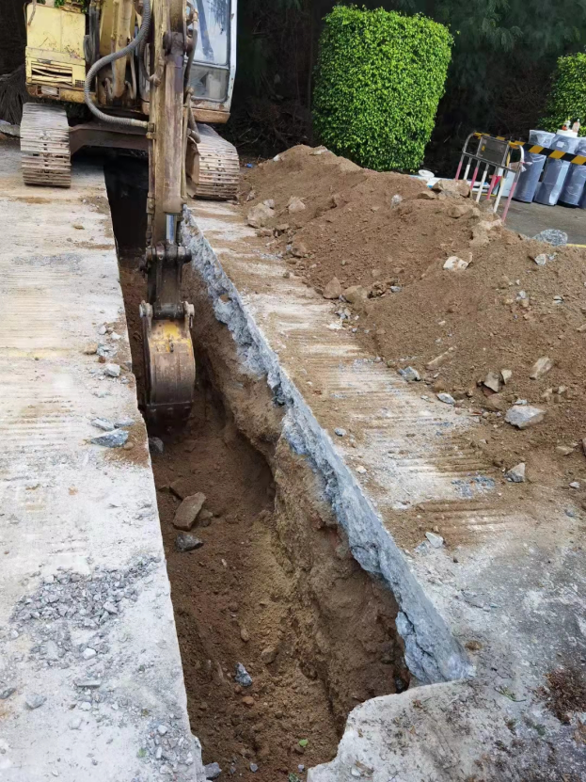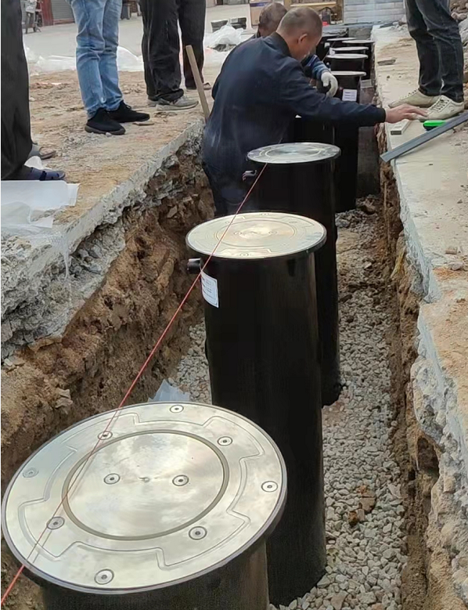

1. After the foundation groove is dug, a suitable amount of sand and gravel can be placed at the bottom to tamp it to prevent the equipment from sinking;
2. Use metal galvanized pipes or PVC pipes, elbows, and tees to connect the wires of each column to the reserved distribution wells, and strengthen the cables to facilitate the later inspection of the equipment. Use iron wire or scotch tape to bind the line pipe to achieve the function of fixing the line pipe, preventing the cable from being crushed when backfilling the concrete, and preventing the concrete from being poured in at the same time. At the same time, a groove of 50*50*150cm (length, width and depth) is dug at the most edge, and is placed in the groove with a PVC hose barrel, which is convenient for the water pump (power: 200-600W automatic pumping) to place and seal.

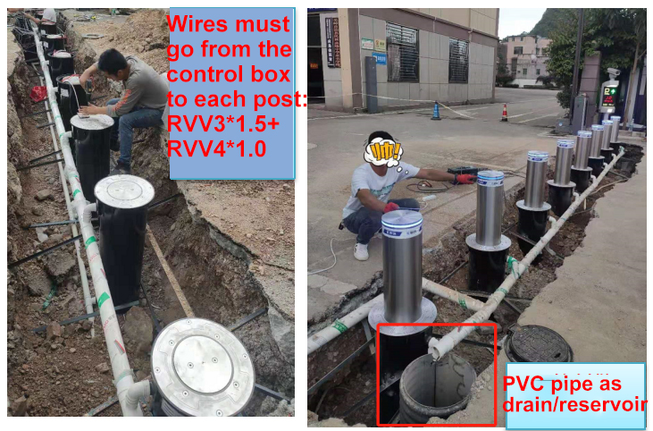

1. Put the equipment into the pit, test whether the hydraulic bollard is running normally with electricity, backfill the equipment with appropriate amount of sand and stones to fix the equipment to ensure horizontal symmetry, and then pour C30 concrete slowly and evenly until it is level with the upper surface of the equipment. (Note: During pouring, the cement can be poured several times until the column is fixed, and then measure whether the hydraulic bollard is level again to prevent it from being moved and dislocated during pouring to make it tilted, and then poured evenly until the surface is level.)

The outermost cable skin is wrapped tightly with waterproof tape repeatedly to prevent water from infiltrating the motor from the cable skin. The two reserved wires in the inner barrel are placed on the flange above the guide post, and the wires are tied to prevent them from falling below the flange, as follows as shown in the figure.

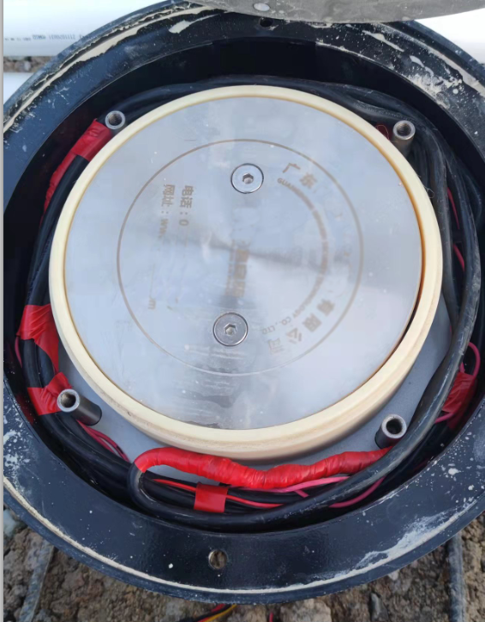

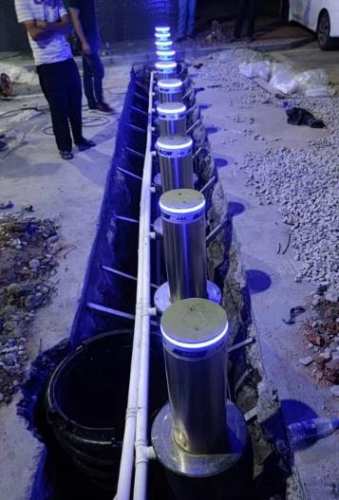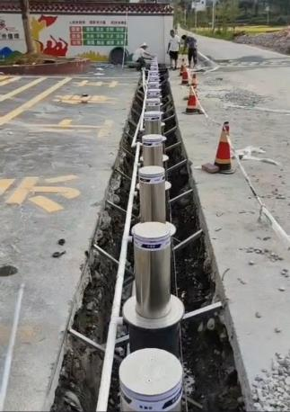

Connect the circuit to the equipment (the wire is wound twice in the cover plate, and a wire of more than 1 meter is reserved for subsequent maintenance), and the operation and debugging of ascending and descending are carried out. Observe the rising and falling of the equipment, adjust the lifting height of the equipment, and check whether there is any deviation of the equipment

1. Concrete pouring

Evenly pour C30 concrete around the equipment to protect the equipment and prevent concrete from entering the equipment. Vibrate the concrete with a vibrating rod to reduce the gap, and finish the surface after 5 hours, and the surface should be flat and light. If the position of the equipment changes during pouring, it should be stopped in time. After the adjustment is completed, continue the construction and complete the secondary pouring work. 24 hours after the secondary pouring is completed, it can be debugged but not open to traffic

Matters needing attention: Before the device is connected to the circuit, all the power cord connectors must be connected with waterproof electrical tape or waterproof connector, including the three-core wire outer skin joints should be sealed and waterproofed with each other, and waterproof treatment should be performed. , observe the rising and falling of the equipment, and adjust the lifting direction of the equipment (if the lifting column is in the opposite direction, adjust and exchange the zero wire (yellow) and the live wire (red) of the motor cable of the lifting column in the control box.

Use double-wall corrugated pipes of at least 30 cm diameter for drainage wells, or use paving (two layers of bricks).

Note: The drain well needs to have a drain pipe inlet, and the drain pipe uses 50 PPR pipe. Make sure to seal the drain.

7：Restore the road

After equipment debugging is correct, backfill cement, lay pavement materials, and restore the road surface.

Note: The wiring port must be in bollard, do not pull into the pipeline, the early installation is not standardized, and the later maintenance is more troublesome. Please construct in strict accordance with the requirements of this instruction. Be sure to confirm that all wiring is correct, and then power on and debug; if you encounter problems, be sure to check after power off.

Note: If the direction of the lift is inconsistent with the direction of the remote control, the motor wire should be reversed, and the motor wire in the control box can be exchanged.

8：Road maintenance

The maintenance period is about 3-5 days. If the motor vehicles need to pass normally during the maintenance period, steel plates shall be laid above the equipment to ensure the smooth flow of the road. Draw yellow and black warning lines or grid lines around the hydraulic bollard according to the requirements of the project party.

After debugging the link number of the control box, conduct a power-on test to ensure that the lift is normal, and the rise and fall are consistent with the remote control side.

9: After the acceptance of the project is passed, deliver the relevant operating instructions and maintenance manuals and other materials and conduct systematic training for the personnel designated by Party A.

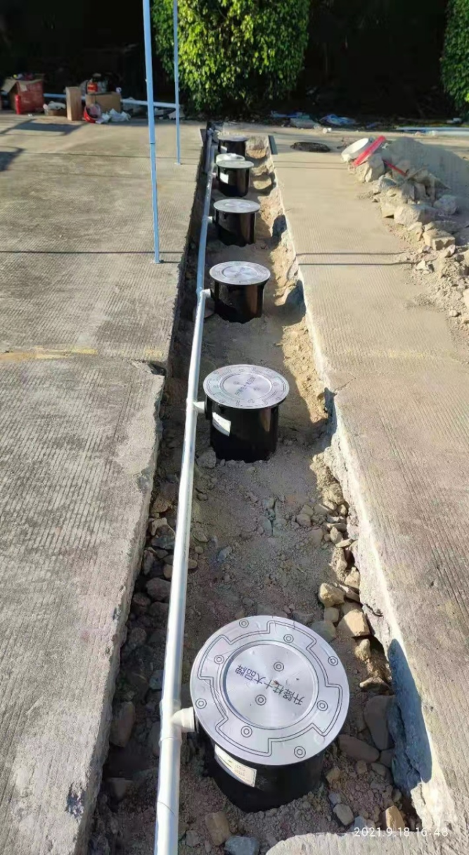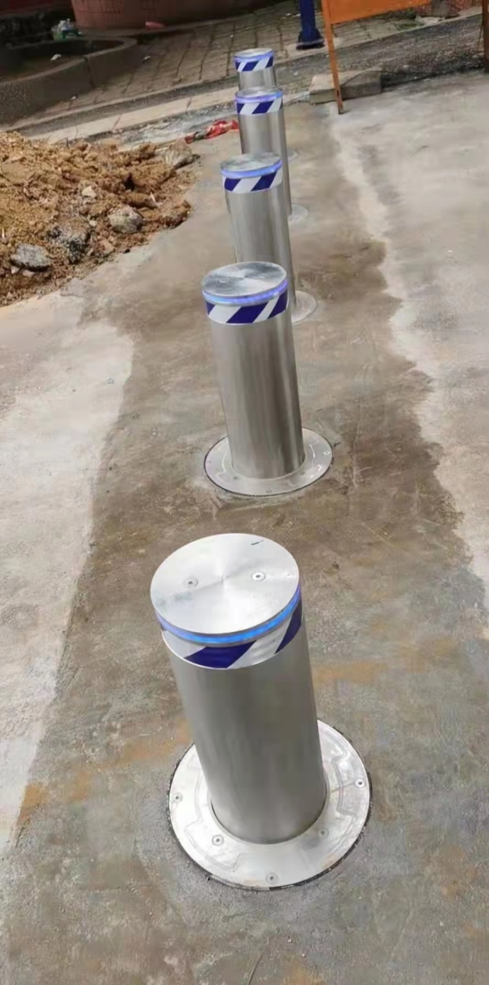

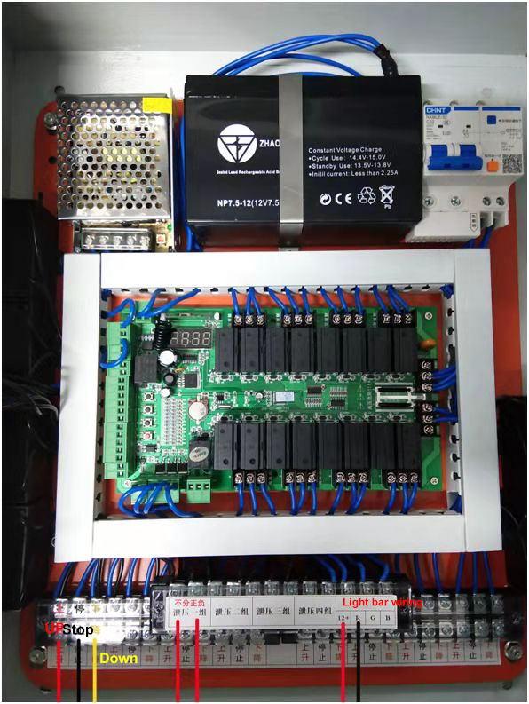**七、Control box wiring diagram**

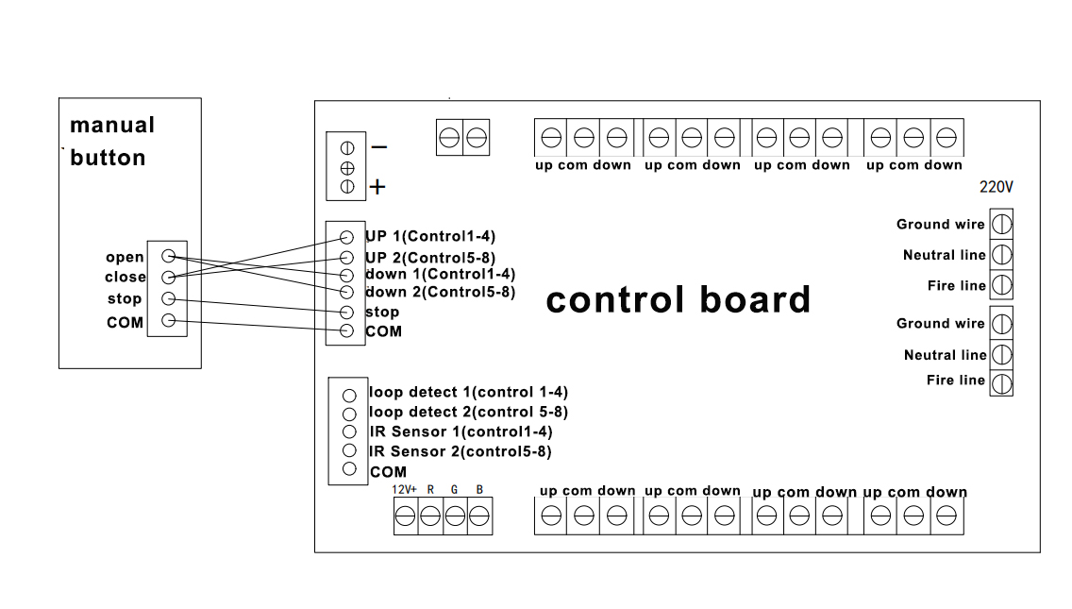

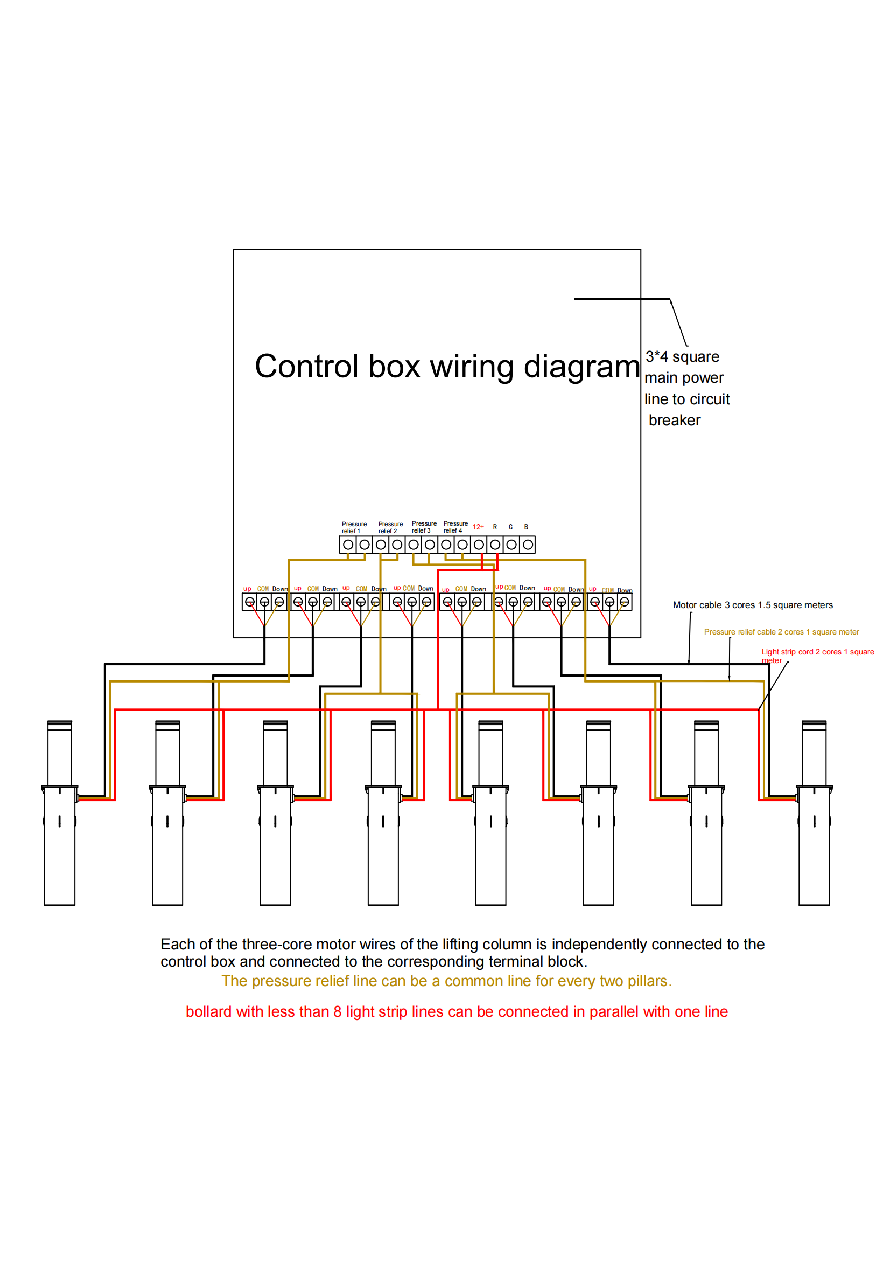

**Equipment operating instructions**

**Wireless remote control column lift**

**There are three buttons on the remote control, which respectively control the lifting and stopping of the Hydraulic bollard press the button** **of the remote control to raise the bollard, press the button** **of the remote control to lower the lifting column, press the button** **of the remote control to stop the lifting column.**

**In case of emergency when the ascending action is not completed, the descending key can be pressed to realize the descending action of the equipment.**

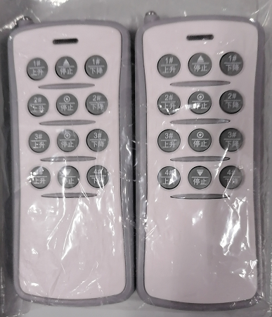

**八、8 Road lift column control main board parameter setting**

**Menu Setup Description**

Control board keys: menu single key, up key, down key, learning key four operation keys.

Description of each function key function:

"Menu key" key: 1: Long press this key in the standby interface to enter the system menu: 2: In the system menu interface, select the corresponding menu and press this key to enter the menu parameter setting interface: 3: After the menu is set, press This key saves the parameters and returns to the system menu interface.

“**上**”：Turn up over the + 1 function when selecting the system menu and setting the parameters

“**下**”：Turn down to the function of-1 when selecting the system menu and setting the parameters

NOTE: In the system menu and menu setting interface, with no button operation within 5 seconds, the system automatically exits the menu to the standby interface.

For example, to change the Group A motor operation protection time operation:

First Steps：**Long press the menu to enter the system menu**，use“**上**”、“ **下**”to check up and down, respectively“**F 0 1**”Menu (see below for the menu description).

The second steps：Press "Menu" to enter the operation protection time of Group A motor setting interface.

The third step：use“**上**”、“ **下**”to add parameter values up and down, respectively。

The fourth step：When the settings are complete, press the menu key to save the exit.

Exit menu: The menu is checked to“**F 10**”menu，Press the menu button to exit the menu manually or automatically exit the menu for 5 seconds.

**Description of the parameter setting of the control board:**

The LED screen displays the software version for about 1 second before the display time.

1. System menu description:

“**F 0 1**”：

Up and drop limit time from line 1 to line 8. Use“**上**”、“ **下**”to increase or decrease the time, respectively, which can be set to 0.1-9.9 seconds.（Factory default is 4 seconds (value 40),40*100ms=1000ms）

1. “**F 0 2**”：

The second road hydraulic bollard motor rise and drop limit time. Use“**上**”、“ **下**”to increase or decrease the time, respectively, which can be set to 0.1-9.9 seconds.(Factory default is 4 seconds (value 40),40*100ms=1000ms）

1. “**F 0 3**：

The 3rd hydraulic bollard motor rise and drop limit time.Use“**上**”、“ **下**”to increase or decrease the time, respectively, which can be set to 0.1-9.9 seconds。(Factory default is 4 seconds (value 40),40*100ms=1000ms）

1. “**F 0 4**”：

The 4th hydraulic bollard motor rise and drop limit time. use“**上**”、“ **下**”to increase or decrease time, can be set to 0.1-9.9 seconds.（Factory default is 4 seconds (value 40),40*100ms=1000ms）

1. “**F 0 5**”：

The 5th hydraulic bollard motor rise and drop limit time. Use“**上**”、“ **下**”to increase or decrease the time, respectively, which can be set to 0.1-9.9 seconds。(Factory default is 4 seconds (value 40)，40*100ms=1000ms）

1. “**F 0 6**”：

The 6th hydraulic bollard motor limit time.use“**上**”、“ **下**”to increase or decrease the time, respectively, which can be set to 0.1-9.9 seconds.（Factory default is 4 seconds (value 40)，40*100ms=1000ms）

1. “**F 0 7**”：

The 7th hydraulic bollard motor rise and drop limit time。Use“**上**”、“ **下**”to Increase or decrease the time, respectively, which can be set to 0.1-9.9 seconds.(Factory default is 4 seconds (value 40),40*100ms=1000ms）

1. “**F 0 8**”：

The 8th hydraulic bollard motor rise and drop limit time. Use“**上**”、“ **下**”to increase or decrease the time, respectively, which can be set to 0.1-9.9 seconds.（Factory default is 4 seconds (value 40)，40*100ms=1000ms）

1. “**F 0 9**”：

Combined control mode of the remote control device. use“**上**”、“ **下**”key to set up separately：

0 For the remote control motor to independently control the bollard motor mode, open the first corresponding rear bollard motor stops working, and then press the remote control key relative to each line and open the second bollard motor.

1 For the second standard mode of the remote control, the first and second lift column motors are opened respectively.

2 To open the four mode of the remote control, the second row of the remote control opens the first to the fourth lift column motor respectively, and the fourth line of the remote control opens the fourth to the eighth lift column motor respectively.

3 For the eighth mode, the fourth line of the remote control opens the first road to the eighth lift column motor respectively.(Factory default is 1)

**Note: The remote control stop key can turn off the lights in any state.**

1. “**F 10**”：

LED operating mode + LED flicker frequency.Use“**上**”、“ **下**”key to increase or decrease the light flicker frequency respectively, can be set to 1-10 parameter value.(Factory default is working mode 1, flicker frequency 2)

1. “**F 11**”：

485 Newsletter IP address. Use“**上**”、“ **下**”key to increase or decrease, respectively, and can be set to 1-99 parameter values.(Factory default is 1)

　12．“**F 12**”

Repeated opening and closing test, mainly used to test the stability of the gate control board and aging test.The digital tube displays 0000 and does not run automatically, Press the main board“**上**”、“ **下**”key to modify the cycle test time separately, if the display 0005 indicates the automatic rise and drop test run after 5 seconds interval. In test mode, press the menu key to exit the test

13“**F 13**”：

Time setting.Press the menu button to enter the time, set, and finally press the menu key to save back.

14“**F 14**”：

The LED timing switch function.Turn off lights forcibly at OFF, ON turn on lights forcefully, and turn on lights regularly at ONC. When ONC, press the menu key to enter the lights on (ON) and (off OFF) time, set, and finally press the menu key to save and go back.(Defile ON lights by default)

15“**F 15**”：

Timed up pressure setting. When OFF, turn off the timing rise and pressurization function, and ON turn on the timing rise and pressurization function. Default (open the timed rise and pressurization function), when ON, press the menu key to enter the pressurization time length setting (0.1s-9s, default (turn on 1.5s) ), and then press the menu key to enter the hour setting of the timing rise and pressurization time, and finally press the menu key to save and return. Default (7:00, minutes are not set)

16.“**F 16**”：

The timing time (cycle) setting of cycle timing pressurization. It can be set to 0-99 gears, the division is 10 minutes (the factory default is 0 gears), 0 is irregular pressurization, 1-99 is pressurized every 10 minutes* (1-99), and the longest is 16.5 Hour. The default pressure execution time is 1.5 seconds, and the pressure execution time can be set in the first option in the F15 option.

17“**F 17**”：

To feel the rise of the court of time. Use“**上**”、“ **下**”key to increase or decrease the rise time, can be set to 0-99 parameter value.(Factory default: working mode is 10,1 second, that is, 1 second after the disappearance of the ground sense 1 or 2.)

**18．**“**F 18**”

Check the software version number and restore the factory settings.Show the C- -time mode,press **停**key to exit to resume the factory settings.Press the menu key to restore the factory settings, and all the parameters of the main board are restored to the factory settings.

**19.** “**F 1 9**”

Exit menu.Or no button operation in 5S will automatically exit

**Port definition description:**

When rising 1 and common give a manual closing switch signal, the 1 to 4 columns perform the rising action

When rising 2 and common give the manual closing switch signal, the 5 to 8 columns will perform the rising action

When stop and public give the manual closing switch signal, the 1 to 8 columns will perform the stop action

When the drop 1 and the common switch signal are manually closed, the columns 1 to 4 will perform the drop action.

When the drop 2 and the public give a manual closing switch signal, the 4 to 8 columns perform the drop action

When the infrared 1 and the common switch signal is closed, the column 1 to 4 will automatically turn to the lowering action during the rising process. If the signal is continuously closed, the upward movement of the column 1 to 4 will be shielded.

When the infrared 2 and the common switch signal is closed, the column 5 to 8 will automatically turn to the lowering action during the rising process. If the signal is continuously closed, the upward movement of the column 5 to 8 will be shielded.

When the ground sense 1 and the public give the closing switch signal, the column 1 to 4 will automatically change to the descending action during the rising process (when the stop has not reached the ascending limit), and the closing signal will automatically perform the ascending action after it is closed to disconnected. If the signal continues When it is closed, it will shield the rising action of the column 1 to 4. (The ground sense signal is invalid after the rising limit stops)

When the ground sense 2 and the public give the closing switch signal, the column 5 to 8 will automatically change to the descending action during the rising process (when the stop has not reached the ascending limit), and the closing signal will automatically perform the rising action after it is closed to disconnected. If the signal continues When closed, it will shield the rising action of the 5 to 8 columns. (The ground sense signal is invalid after the rising limit stops)

1. Learn the code, hold down the learning key in the control motherboard for about 2 seconds, release when the remote control learning light is on (LED digital tube shows LEAN), use the remote control handle any key to continuously code, the circuit has the corresponding action after the successful learning.Note: If the controller does not receive the code within 6 seconds, the learning state is automatically withdrawn
2. Remove the code, hold the learning key inside the control motherboard (about 9 seconds), the remote control learning indicator is off (LED digital tube displays Er- - -) until the remote control indicator is off, and the elimination code is completed

Special note: After a period of use, if the remote control distance is shortened, please check whether the installation position of the host will be covered by metal or the battery power is sufficient, the remote control uses DC12V, 23A battery, pay attention to replacement.Remote control distance is greatly affected by the weather. In the rain, fog, wind, and other harsh weather conditions, the remote control distance is shortened, which is a normal phenomenon.

**九、Matters need attention；**

1. Avoid frequent lifting operations in a short period of time, which will cause the motor to heat up and may cause the motor to burn out.

2. When using the remote control to raise the lifting column, please pay attention to whether there are pedestrians or vehicles around the lifting column to avoid unnecessary injury and damage to pedestrians and vehicles.

3. When the lifting column is not working properly, please press it once to stop when the lifting and lowering are completed, so as to avoid damage to the internal components and unable to stop, which will cause the motor to burn out.

4. When it is found that the mechanical operation of the lifting column motor continues after the individual lifting column is in place during use, you should press it to stop immediately, and carefully observe whether the motor is running. When you are sure that it has stopped, contact the professional in time.

5. It is strictly forbidden to fill the gaps around the cylinder with sediment and debris, which will affect the normal lifting of the cylinder.

6. It is strictly forbidden to scribble on the surface of the cylinder, causing damage to the surface of the cylinder and affecting the normal lifting of the cylinder.

7. Do not disassemble the structure of the equipment without the guidance of professionals designated by us. Disassembly under non-professional guidance is extremely easy to cause equipment leakage, damage to accessories and other faults. The fault caused by disassembling the equipment by yourself is not covered by the company's warranty.

8. Emergency measures: When the equipment is in the rising state and the power grid is out of power, the control system of the distribution box cannot be started normally due to the power outage. There is a 12V lead-acid battery in the distribution box. In order not to affect the normal passage of the vehicle, long press the pressure relief button of the emergency lowering solenoid valve of the control box, and the lifting column will automatically drop to level with the ground. When moving, artificial downward pressure can be applied until the column is level with the ground.

**Daily maintenance**

Regular inspection and maintenance are fundamental to ensuring that equipment is working at optimum efficiency. When performing equipment maintenance

When caring, please pay attention to the following aspects:

1. During electrical maintenance, the relevant power supply should be cut off, and maintenance and inspection signs should be hung in a prominent position.

2. Check the working conditions of switches, buttons and indicator lights once a month.

3. Check whether the screws on the terminals and electrical components are loose once a month.

4. Regularly carry out dust removal maintenance on the equipment surface, electrical control system and hydraulic control system.

5. Regularly tighten the screws of the transmission mechanism and mechanical fixing mechanism of the equipment.

6. Regularly (six months to one year) refuel, lubricate and maintain the cylinder.

**十、Cause of the fault and the treatment method**

|  |  |  |
| --- | --- | --- |
| Fault phenomenon | Failure analysis | Solution |
| After the cylinder is in place, it slides down | Lack of hydraulic oil | increase hydraulic oil |
| Slowly descend after rising | Relief valve failure | Swap relief valve |
| Stop in the middle of the descent and slowly descend | Relief valve failure | Adjust the relief valve or replace the top spring inside the valve body |
| After rising to the right position, the external pressure is applied, and the oil leaks after sliding down Replace the oil seal | oil spill | Replace the oil seal |
| Cylinder does not rise or rises very slowly | 1. Failure of the relief valve  2. Lack of oil | 1. Power up and drop, and flush the pressure relief valve  2. Make an addition to the hydraulic oil |
| The cylinder cannot rise or fall | Check mains power  Check the power supply of the lifting columnl | 1. Check that the controller is powered on  2. Check whether the main electric leakage switch is turned on  3. Check whether the electric electric leakage switch is turned on  4. Check whether the electric leakage switch cable is connected to the wrong wire  5. Check whether the electric leakage switch is energized |
| The column does not move, and it is difficult to ascend | 1. Mechanical deformation, high friction  2. Uneven mechanical clearance and large friction | 1. Add lubricating oil to the mechanical friction area  2. Correct the mechanical structure and replace the uneven parts  3. Adjust the mechanical clearance |
| The column can be raised but not lowered, half-up to stop, half-down to stop | 1. The capacitor UF is not enough  2. The cable is too long  3. The voltage is unstable | 1. Replace the corresponding power capacitor  2. Increase the square number of cable lines |
| Replace the voltage-stable transmission flow  Lift column lift process trip, or  Pre-buried process trip | 1. Voltage instability  2. The cable line is too long  3. Cable line interface string line | 1. Replace the voltage-stable power transmission flow  2. Increase the square number of cable lines  3. The interface is repeatedly wound with waterproof glue, or wired with a waterproof junction box  4. Insufficient leakage switch installation |
| Lift reversal | Press remote control up actually down remote control down actually up | Lift column zero line fire line connected against the adjustment |
| LED 灯不亮 | 1. The line is not connected well  2. Line connection and reverse | 1. Check whether the lamp cable is energized  2. Two-line adjustment |